FATS AND OILS
BEHAVIOUR OBJECTIVES
At the end of this lesson, students should be able to:
- distinguish between fats and oils
- outline at least 3 physical and chemical properties of fats and oils.
- outline at least 5 uses of fats and oils
- explicate saponification and hardening of oils
- test for fats and oils
- draw and label the structure of soap and detergent
- outline the cleansing action of soap and detergent using schematic diagrams.
- distinguish between soaps and detergents.
- enumerate the advantages and disadvantages of soaps and detergents

Fats and oils belong to a group of compounds known as lipids.
Fats and oils share common chemical structure and similar properties, the only difference is that fats are solids and are commonly obtained from animal sources like milk, beef, pork, etc. while oils are liquids and are commonly obtained from oil producing plants like peanuts, soya beans, palm kernels, groundnuts, olives, etc.
Fats and oils are esters of trihydric alkanol

STRUCTURE OF FATS AND OILS
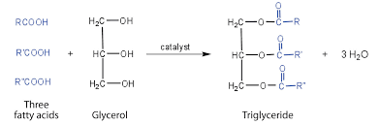
The fatty acids in fats and oil can be classified into;
- Saturated fatty acids: have no double bonds in their hydrocarbon chains
- Unsaturated fatty acids: have one or more double bonds in their hydrocarbon chains.

PHYSICAL PROPERTIES OF FATS AND OILS
Fats or oil are complex mixture of propane-1,2,3-triol esters, so their properties depends mainly on the proportion of the other components. Generally;
- Fats have higher melting points because they consist of higher proportion of esters of saturated fatty acids.
- Oils have lower melting points because they consist of higher proportion of esters of unsaturated fatty acids.
- They are insoluble in water but soluble in organic solvents e.g. alcohols.
- Decompose at temperature above 300ºC.

CHEMICAL PROPERTIES OF FATS AND OILS
- Hydrogenation of oils: the process of changing oils to solid fats, and it is called hardening of fats. It involves passing hydrogen into an unsaturated oi at about 200ºC and 5atm in the presence of a finely divided nickel catalyst. The hardened oils can then be mixed with salt, vitamins, skimmed milk and various fat to form margarine.
Vegetable oil $\underset{↔}{ Ni catalyst, high. temp }$ Margarine
- Saponification: Hydrolysis of fats and oils with caustic alkalis will yield propane-1,2,3-triol and the corresponding sodium or potassium salts of the component fatty acids.
Fats + caustic alkali → soap + propane-1,2,3-triol
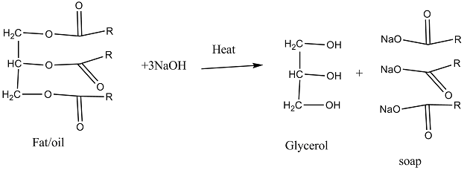
USES OF FATS AND OILS
- Most fats are consumed as food.
- Oils are hardened in the production of margarine.
- Used in the production of soaps, glycerol.
- Used as solvents for paints.

TEST FOR FATS AND OILS
SUDAN III TEST: add about 3cm³ vegetable oil, about 4cm³ of water in a boiling tube, and shake. Then add 3 or 4 drops of Sudan(III) stain. A red stain will be formed.
PAPER TEST: add a few drops of vegetable oil on a piece of white paper or filter paper. Translucent spot will be observed on the paper.

SOAP
Soap is the sodium or potassium salt of fatty acids that has cleaning action in combination with water. Hard soaps are sodium salts of fatty acids while soft soap are potassium salts of fatty acids.
Each molecule of soap possesses a long hydrocarbon chain R, attached to an ionic head which is either COO⁻Na ⁺ or COO⁻K⁺. The hydrocarbon tail is HYDROPHOBIC (water-hating), it is insoluble in water, but soluble in oil or organic solvents while the ionic head is HYDROPHILIC (water-loving), it is soluble in water.
STRUCTURE OF A SOAP MOLECULE
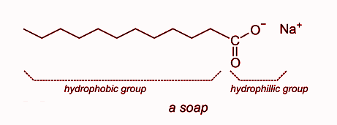
CLEANSING ACTION OF SOAP
When soap solution is applied to grease-coated piece of fabric, the soap molecule first approaches the grease spot. At the interphase of grease and water, the hydrophobic tails of the soap particles dissolve in grease while the hydrophilic heads dissolve in water. The water molecules attract polar ionic heads of the soap molecules. This action helps to lift the grease spot upwards, enabling more soap particles to dissolve in the grease. Eventually, with mechanical scrubbing, the grease patch is emulsified. On rinsing the fabric, the grease is removed. The Cleaning Action of Detergent is the same as that of Soap.

ADVANTAGES OF SOAP
- Soaps are biodegradable so do not cause pollution.
- Forms good lather with soft water (works well).
- Soaps are cost effective and readily available.

DISADVANTAGES OF SOAP
- Forms less lather with hard water.
- Less effective in saline or acidic water.
- Soap is alkaline, so it can irritate sensitive skin.

LABORATORY PREPARATION OF SOAP
- A mixture of about 100cm³ of vegetable oil (palm kernel oil) and 100cm³ of 10% sodium hydroxide solution is boiled and agitated by passing steam until it is homogeneous.
- Saturated solution of sodium chlorine (brine) is then added to the slightly coked mixture, in order to sort out or separate the soap and from the mixture of propane-1,2,3-triol (glycerol).
- The soap cord obtained is then slightly dried and mixed thoroughly with perfumes and covalent.
- Again, the soap is slightly dried, then pressed before being cut into tablets or bar.

DETERGENT
Detergents are cleaning agents made of sodium or potassium salt of long-chain alkyl hydrogentetraoxosulphate(VI), R-SO₃H. The general formula of detergent is R-SO₃⁻ Na⁺ or K⁺. where R is straight hydrocarbon chain of carbon atoms, the detergent will be biodegradable, if branched; it will be non-biodegradable.
NB: THE CLEANING ACTION OF DETERGENT IS THE SAME AS THAT OF SOAP.

STRUCTURE OF DETERGENT
Detergent molecule has a hydrophobic tail and a hydrophilic head. The hydrophobic tail is either a long chain hydrocarbon (usually 12 to 18 carbon atoms long) or benzene ring with a long alkyl group attached.
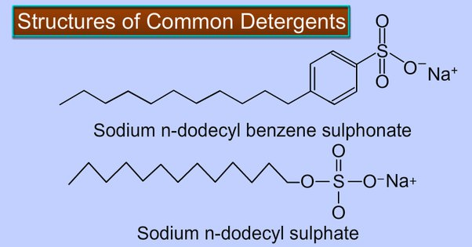.
R is a long hydrocarbon chain.
The High Solubility of Detergents in Water is due to the -SO₃⁻Na⁺ group that is present in the molecules.

ADVANTAGES OF DETERGENT
- Forms lather easily with hard water.
- Can be used in saline and acidic water.
- More easily soluble in water than soap.
- Detergents with linear hydrocarbon chains are biodegradable.

DISADVANTAGES OF DETERGENT
- Detergents with branched hydrocarbon chains are non-biodegradable so can cause pollution.
- More expensive than soap.
- More water is required in rinsing to remove the foam; else, the fabric will be damaged.

SOAP | DETERGENTS
Consists of -COONa group attached to fatty acid having long alkyl chain.  All soaps are biodegradable.  Do not dissolve in saline water or hard water.  Natural oils and fats are used in the preparation of soaps. | Consists of -SO₃Na group attached to a long alkyl chain.  Some are biodegradable while others are not.  Dissolves in saline and hard water.  Synthetic detergents are made from petroleum hydrocarbons derived from natural gas.

DRILL QUESTIONS

- Hydrolysis of fats and oil to yield alkanol and soap is called
- Esterification
- Hydrogenation
- Hydrolysis
- Saponification

- Fats and oils belong to a general group of compounds known as
- Glycerol
- Soap
- Margarine
- Lipids

- Hydrophobic tail of soap dissolves in grease while hydrophilic head dissolves in
- Water
- Benzene
- Propanol
- Kerosene

- Detergents are manufactured with straight hydrocarbon chains in order to make them
- Soluble
- Biodegradable
- Cheaper
- Foamy

- Detergent can be used in
- Soft water only
- Hard water only
- In both soft and hard water
- All the ionic solvents

ANSWER
- D
- D
- A
- B
- C

